Light and Reflection
Problem 13 C
CONVEX MIRRORS
PROBLEM
You have just received a silver key ring as a gift. The ring is connected to a spherical silver ball that acts like a convex spherical mirror. When you hold the ball 21 cm from your eye, your image forms 7.0 cm behind the mirror. What is the magnification of the image? What is the mirror’s focal length and radius of curvature?
SOLUTION
Given: p = 521 cm q = −7.0 cm
Unknown: M = ? f = ? R = ?
Choose the equation(s) or situation: Use the mirror equation to find the focal length and radius of curvature, and the equation for magnification to find the height of the image.
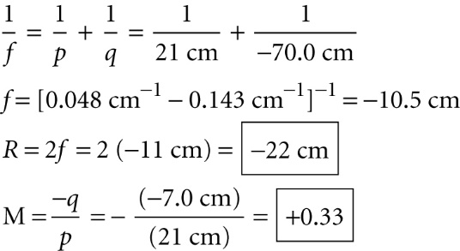
ADDITIONAL PRACTICE
1. A convex mirror with a focal length of 0.25 m forms a 0.080 m tall image of an automobile at a distance of 0.24 m behind the mirror. What is the magnification of the image? Where is the car located, and what is its height? Is the image real or virtual? Is the image upright or inverted?
2. A spherical glass ornament is 6.00 cm in diameter. If an object is placed 10.5 cm away from the ornament, where will its image form? What is the magnification? Is the image virtual or real? Is the image inverted or upright?
3. You see an image of your hand as you reach for a polished brass doorknob. The doorknob has a focal length of 6.3 cm. How far from the doorknob is your hand when the image appears at 5.1 cm behind the doorknob? What is the magnification of the image?

4. As you turn the knob of a faucet to draw bath water, you see your reflection in the water spout. The focal length of the spout is −33 cm. How far away from the spout are you if your image appears to be 16.1 cm behind the spout? What is the magnification of the image?
5. You see your reflection in your friend’s mirrored sunglasses. If each lens has a focal length of −12 cm, and your image appears 9.0 cm behind the sunglasses, how far from your friend are you standing? What is the magnification of the image?
6. To supervise customers, many stores install spherical convex mirrors in strategic locations. Suppose one store has a spherical convex mirror with a magnification of 0.11. Suppose you are 1.75 m tall.
a. How tall is the image?
b. How far in front of the mirror are you when the image appears 42 cm behind the mirror?
7. A stainless-steel ladle, used to serve soup, is like a spherical convex mirror. If the focal length of the ladle is 27cm and you are 43 cm in front of the ladle, where does the image appear? What is the magnification of the image?
8. Just after you dry a spoon, you look into the convex part of the spoon. If the spoon has a focal length of −8.2 cm and you are 18 cm in front of the spoon, where does the image appear? What is the magnification of the image?
9. The base of an art deco lamp is made of a convex spherical mirror with a focal length of −39 cm.
a. Where does the image appear when you are 16 cm from the base?
b. If your nose is 6 cm long, how long does the image appear?
10. The button on many electric hand dryers is a convex mirror. You see the image of your hand as you reach to press the button. If the magnification of the image is 0.24 and your hand is 12 cm away from the button, where does the image appear?

